**Dress Code**

Belief Statement

Our school dress code creates a sense of community. Students wearing the dress code will:

* Promote a sense of pride in our school.
* Promote self-esteem.
* Eliminate inequality and unnecessary competition.
* Promote a positive image of our school in the community.
* Support student safety through ease of identification
* Ensure students are dressed appropriately for all school activities.

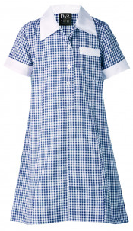All students are expected to be in uniform. If a student is unable to wear uniform, they will be directed to the front office to borrow one for the day. This will be returned to the office at the end of the day.

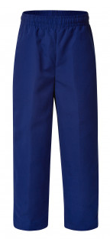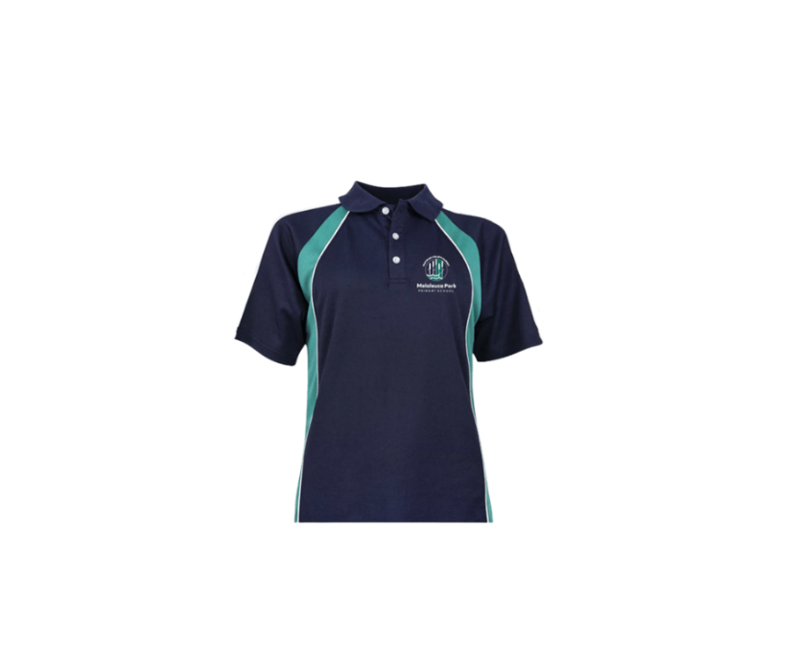

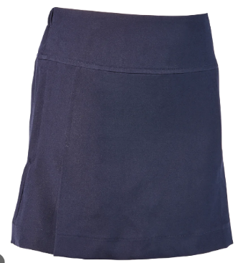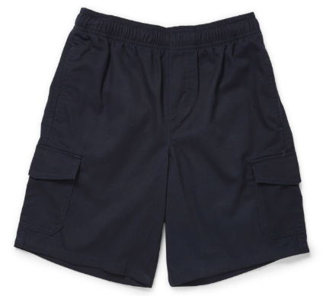

Policy Statement

Our Governing Council, in co-operation with the Principal and staff, supports the School Dress Code, as permitted under the Education Act.

* All students are required to wear clothing that is consistent with the School Dress Code for activities and learning on and off site. This includes official school activities and class excursions.
* No logos, apart from the school logo, are permitted on any items of clothing.
* The school has a sun safe policy where each child is expected to wear a hat when outdoors during term 1 and 4 and during high UV rating in term 3. Hats are to be broad brimmed, legionnaire or bucket style. No caps are to be worn.

Dress Code

Girls: Navy jumper, navy and teal or navy polo shirt, navy skirt, navy pants, navy shorts, navy and white check summer dress.

Boys: Navy jumper, navy and teal or navy polo shirt, navy pants, navy shorts.

Shoes: Sneakers, shoes or sandals. Slip on shoes, thongs or shoes with a high heel are not acceptable as they can cause a safety issue to students.

Plain navy clothing is available from local shops. Navy and teal clothing with the school logo can be purchased at the front office.

Year 6 jumpers will be in school colours with the design negotiated annually.

Exemption

Parents can apply for exemption for their child through a written request to the Principal. Grounds upon an exemption may be considered are:

* Religious
* Cultural or ethnic
* Itinerant students
* Financial hardship

Endorsed by Governing Council: 5/12/22